## Project Description

Temple Tracker will help users record and track details related to their temple attendance. The target audience members include members of the LDS church and ward or stake leaders. Temple Tracker allows groups to anonymously report and track their collective temple attendance. This would be especially useful in wards that want to encourage temple attendance.

## Design Overview

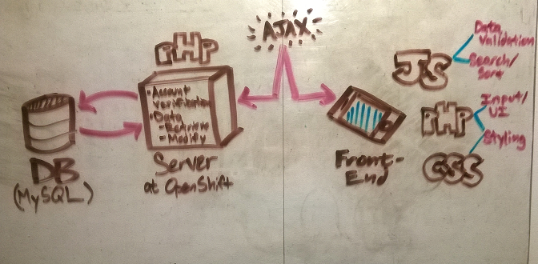

## Database Entities

**“user_table”**

|  |  |  |  |  |  |
| --- | --- | --- | --- | --- | --- |
| **User_id** | **email** | **pass** | **settings** | **User_info** | **Group_list** |
| INT UNSIGNED | VARCHAR(32) | VARCHAR(16) | VARCHAR(128) | VARCHAR(128) | TEXT  (“group_id, …”) |

**“group_table”**

|  |  |  |  |  |  |  |
| --- | --- | --- | --- | --- | --- | --- |
| **group_id** | **admin** | **Member_list** | **Invite_list** | **Start_Date** | **End_Date** | **Name** |
| INT UNSIGNED | INT UNSIGNED  (user_id) | TEXT  (“user_id, ...”) | TEXT  (“email, …”) | DATETIME | DATETIME | VARCHAR(32) |

**“visit_table”**

|  |  |  |  |  |  |
| --- | --- | --- | --- | --- | --- |
| **Visit_id** | **Ordinance** | **Date** | **Quantity** | **Note** | **Contributor** |
| INT UNSIGNED | VARCHAR(2) | DATETIME | INT UNSIGNED | TEXT  (“I am happy…”) | INT UNSIGNED  (user_id) |

## Database Retrieval

Not all data will be displayed directly to the user. In fact, most of it will simply feed back-end logic & authentication.

Data sent and received between front and back ends will be in stringify()’d JSON format.

The following events show which data are likely to be those most commonly requested by users:

* **Login** – “settings” & “user_info” will be returned to user. User “email” & “pass” will be stored in a PHP session variable and used for authentication purposes in the following data update/retrieval requests.
* **View My Visits** – all rows from “visit_table” where “contributor” is equal to “user_id” of current user will be returned to user
* **View Groups** – SELECT name FROM group_table WHERE <group_list[i]> = group_id  
  (that’s far less wordy a description, don’t you think?)
* **View Group Visits** – SELECT * FROM visit_table WHERE contributor = … well it gets complicated. I’m unsure whether this will require an inner SELECT or an INNER JOIN, but I’ll have it figured out soon enough.

## Database Update

The following events show which existing data are most likely to be modified by user requests:

* **Change Visit Details** – “Ordinance”, “Quantity”, “Note”, and even “Date” of any “visit” may be modified by a user whose “user_id” = “contributor” of that visit. There are way too many “” going on here…
* **Create a Group** – This will prompt the creation of a new row in the “group_table”. This person will be the group admin. They’ll have to use the Temple Tracker app to create a list of email addresses of those who are invited to the group. Admin will also designate the “start_date” of that group’s visit logging, and may also enter an “end_date”.  
  After this, there’s very little a group administrator can do aside from deleting the group or changing the “end_date”.
* **Join a Group** – “settings” from the “user_table” will contain invites to groups sent by group admins. Accepting an invite to a group results in the user’s “user_id” being added to the “member_list” of that group.
* **Change My Account Settings/User Information** – I’m not super clear on what exactly will constitute ‘account settings’ or ‘user information’ yet. I’ve got ideas, but I’m sure the necessities will reveal themselves to me in due time.

I’m lacking a lot of detail here, but hey, this is a proposal, not a spec, am I right??